**Github:**

https://github.com/jadenthenanalyst/CMPR114-VScode/tree/main/Week%205/InClass

**Challenge Exercise #1**: using project #3, add to the code so that the user can enter or input the number of birds in each state.

**#1 print screen the output with code below here.**

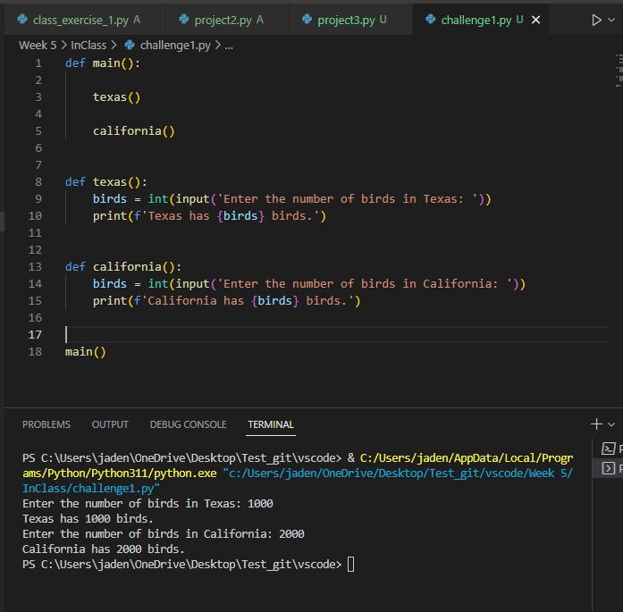

**Challenge Exercise #2:** Create a program with a *function* that will allow the user to enter the last, first names, address, city, state, with zip code.

**#2 print screen the output with code below here.**

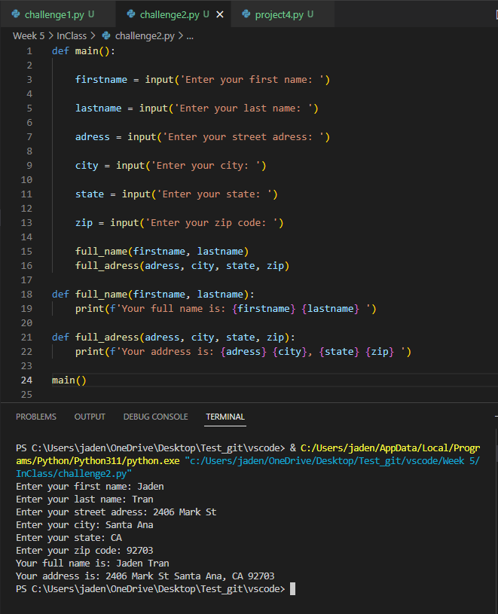

**Challenge Exercise #3:** Modify the project #5 to add three numbers.

**#3 print screen the output with code below here.**

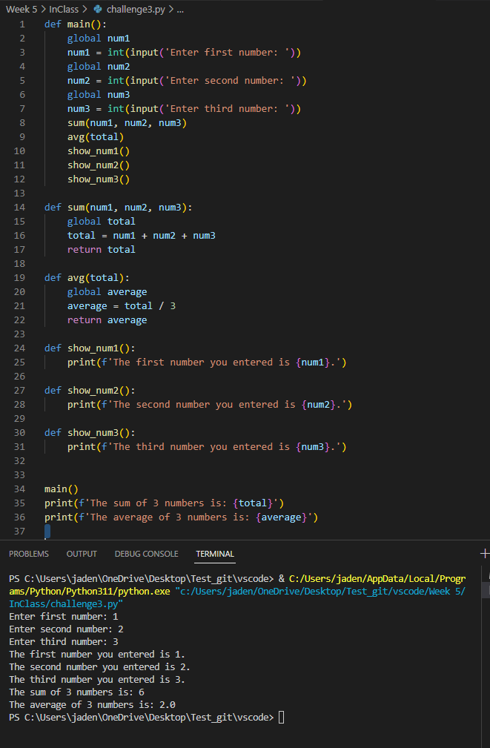

**Challenge Exercise #4:** Modify the project #5 so the user can enter or input any three numbers, be sure to use global variables in the program. Also, sum and average the three numbers.

**#4 print screen the output with code below here.**

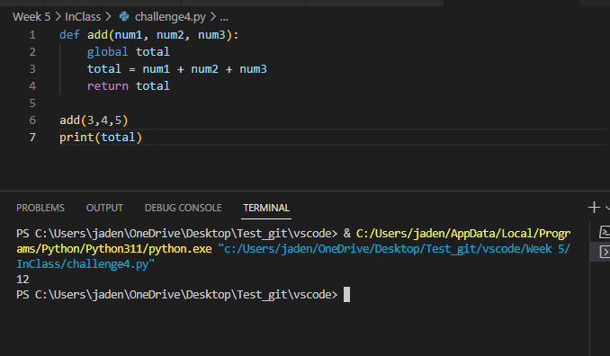

**Challenge Exercise #5:** using a **function** and **setting** and **passing** **arguments**, create a program that will ask the user to enter the hours worked, and hourly pay. Then get the output in a print statement.

**#5 print screen the output with code below here.**

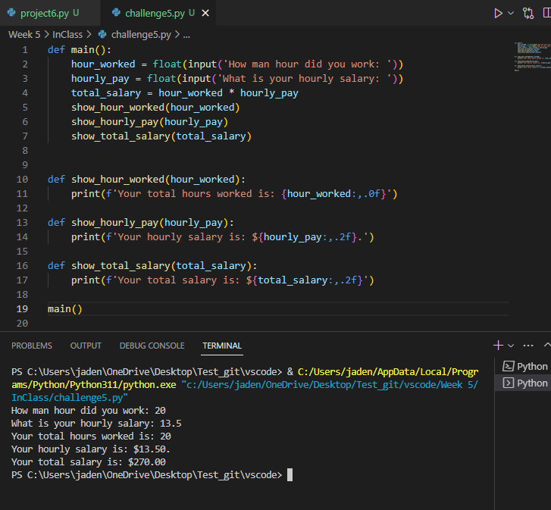

**Submit this document to Module 5 Class Exercise.**